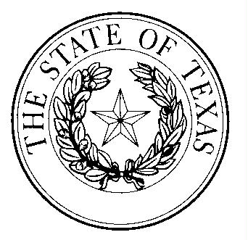

B A Y L O R C O U N T Y
OFFICE OF
COUNTY JUDGE
119 NORTH WASHINGTON ST.
SEYMOUR, TEXAS 76380

RUSTY STAFFORD, JUDGE PHONE # 940-889-3553
EMAIL judge@srcaccess.net FAX # 940-889-8856

BAYLOR COUNTY COVID-19 TESTING SITE

The Seymour Hospital located at 200 N. Stadium Drive provides COVID-19 testing for anyone with symptoms or combinations of symptoms:

- Cough
- Shortness of breath or difficulty breathing
Or at least two of these symptoms:
- Fever
- Chills
- Repeated shaking with chills
- Muscle pain
- Sore throat
- New loss of taste or smell

